FEEDBACK AND COMPLAINTS POLICY

- OVERVIEW
FUTURE DREAMS welcomes feedback, good or bad. Anyone receiving or affected by our services can complain, offer suggestions or give praise. All feedback is treated in confidence. FUTURE DREAMS appreciates positive comments when things go well, and also recognises that sometimes things go wrong or that we may not meet our services standards. If they do, we will apologise and aim to put things right promptly and fairly at an early stage. No-one will receive any different treatment because of feedback. We will learn from managing and resolving complaints to ensure we make real improvements to our services, and appreciate stakeholder feedback to let us know what is working well, whether we can make further improvements, and ideas or suggestions about how to better deliver services to our customers.

- PURPOSE
- To set out a single, clear and consistent process for staff and volunteers to follow when they handle feedback and complaints about Future Dreams.
- To set out how we can best capture, act upon and learn from the feedback and complaints in an open and transparent way.
- To provide a direct and positive connection between those who provide the services and those that use them.
- To provide a rich source of learning for the Future Dreams team to improve services.
- To show people using Future Dreams services how to give feedback or make a complaint and ensure that their feedback and complaints are taken seriously and addressed.
- To ensure our staff are provided with the right training to handle feedback and complaints and are supported and involved in the process.

- SCOPE
- The policy covers how to openly welcome and deal with feedback and complaints.
- The policy applies to all staff, volunteers, instructors, hosts and therapists providing Future Dreams services, who interact with people who use, or support others to use, their service.
- This policy also outlines to those that use Future Dreams’ services how feedback and complaints can be received and how they are acted upon and learnt from.

- DEFINITIONS
- Feedback: an opinion, whether invited or spontaneous, that can be positive, negative or neutral. Effective feedback contributes to growth, learning, and a positive work environment.
- Complaints: Complaints highlight pain points, issues, or dissatisfaction and require a response. While negative, they offer opportunities for improvement and resolution
- Channels: User feedback can come from various channels such as:
  - Surveys
  - Emails sent to info@futuredreams.org.uk or support@futuredreams.org.uk
  - Calls
  - WhatsApp chats
  - Via Community Group hosts, practitioners or therapists
  - Social media
  - Treks and Challenges
  - Fundraising events

- ROLES AND RESPONSIBILITIES
- Board of Trustees
The FUTURE DREAMS Board of Trustees has overall responsibility for the handling of feedback and complaints and ensuring that appropriate action is taken. The Board will monitor performance on an annual basis.
- Senior Management Team: The Management Team is responsible for how the charity handles and learns from complaints. They are also responsible for ensuring this policy is discharged effectively across their departments and communicated to all staff, and their responsibilities are carried out under this policy. They will:
  - make certain that feedback and complaints are openly welcomed through suggestion boxes, comment books and clear instructions on the website advising people how to give feedback /make a complaint.
  - ensure that all staff, volunteers and representatives have a basic understanding of their roles and responsibilities with respect to feedback and complaints.
  - ensure training is made available to all key personnel to support them in handling feedback and complaints in a fair and transparent way and the training provided will respect diversity in relation to culture, race and disability and promote equality.
  - ensure feedback and complaints are acted upon and opportunities for learning take place.
  - SMT will monitor performance at monthly Operations Meetings.
- Managers: All Managers will ensure their teams are carrying out their responsibilities in accordance with this policy and the associated procedure and that training is attended by key personnel. The level of training required for each staff member is dependent on their degree of contact with people using the services. This will include staff working at Future Dreams House or online.
- Complaints staff: staff who have a specific responsibility to look into and investigate complaints. Complaints staff will ensure:
  - All feedback and complaints are logged in the feedback and complaints spreadsheet with follow up actions recorded.
  - All feedback and complaints are taken seriously and responded to appropriately.
  - Where appropriate, Managers will assess the information promptly and carefully, clarifying or obtaining more information about the matter as appropriate.
  - Provide training appropriate for all levels of staff with particular focus on staff with customer facing responsibilities.
  - People using the services are provided with information of how to give feedback or make a complaint.
- Staff: includes all staff, volunteers, instructors, hosts, therapists providing Future Dreams services who interact with people who use, or support others to use, their service. They have a responsibility to actively welcome, record and act upon feedback and complaints.
  - All should ensure they are aware of, and comply with this policy and associated procedures and attend training as required.
  - Ensure staff, volunteers and tenant representatives understand the level of training appropriate for their post and that they feel confident in working within this environment and able to communicate with their managers to ensure that they have the knowledge and skills to carry out their tasks in relation to feedback and complaints.

- RECORDING AND MONITORING
All staff are responsible for recording customer feedback and complaints.
Recording customer complaints is not only a way to keep track of the issues and solutions, but also to comprehend the root causes, patterns, and impacts of the complaints. Doing so can help you identify and address common problems that affect customer satisfaction and loyalty, improve your products, services, and processes based on customer feedback, monitor and measure customer service performance and quality, set goals for improvement, communicate and collaborate with your team and other departments to share information and best practices, and demonstrate your commitment to customers, thus building trust and rapport.

Feedback and complaints to be recorded in a centralized spreadsheet that the Senior Management and Complaints Managers have access to. To include:
  - Subject/title – write down the type of complaint (service quality, pricing, or staff, etc)
  - Information about the customer – including their name and contact information
  - Date – when it happened so that you have a timeline
  - Details of the complaint – what they said about the problem
  - Resolution – include what was done to resolve the complaint and how the customer felt about it

- PROCESSES

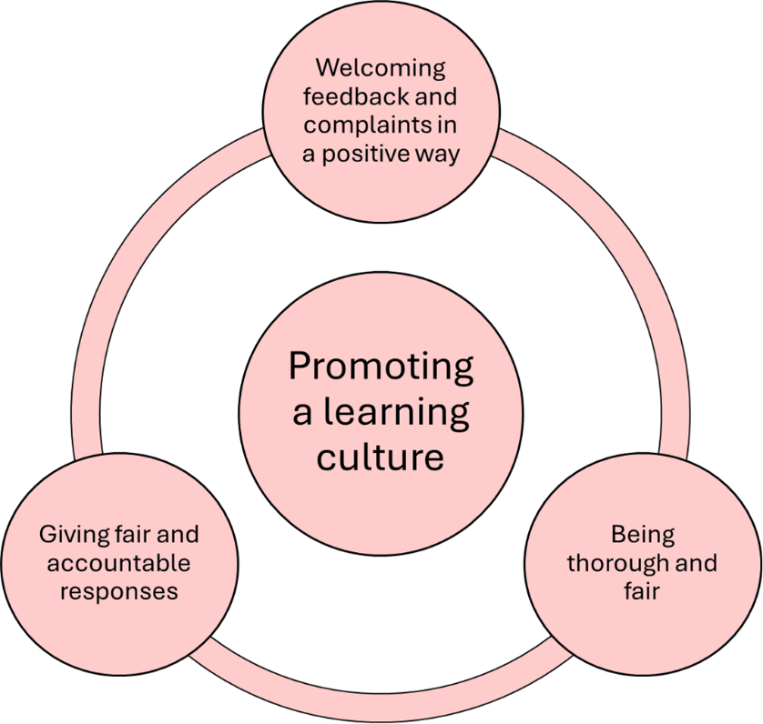

- Feedback Process
  - Encourage Feedback

- Complaint Feedback
  - Acknowledge the customer immediately and listen carefully without interrupting.
  - Apologise to the customer whilst remaining polite, calm and professional.
  - Summarise the complaint back to the customer letting them know you understand their frustration.
  - Solve the problem as quickly as possible by explaining the action you will take.
  - Check with the customer to ensure they are satisfied with the outcome.
  - Thank the customer for their understanding and patience.
  - Record complaint in the complaints book.

